**CHANDIGARH UNIVERSITY**

**UNIVERSITY INSTITUTE OF ENGINEERING**

**DEPARTMENT OF COMPUTER SCIENCE & ENGINEERING**



|  |  |
| --- | --- |
| **Submitted By:** Sahil Kaundal  **Submitted To:** Neeru Sharma | |
| **Subject Name** | Programming Based Learning Java (Lab) |
| **Subject Code** | 20CSP-321 |
| **Branch** | Computer Science Engineering |
| **Semester** | 5th |

LAB INDEX

**NAME:** Sahil Kaundal **SUBJECT NAME:** PBLJ (Lab)

**UID:** 21BCS8197 **SUBJECT CODE:** 20CSP-321

**SECTION:** 20BCS_WM-616/A

|  |  |  |  |  |  |  |  |
| --- | --- | --- | --- | --- | --- | --- | --- |
| **Sr.No** | **Program** | **Date** | **Evaluation** | | | | **Sign** |
| **LW**  **(12)** | **VV**  **(10)** | **FW**  **(8)** | **Total**  **(30)** |
| 1. | Create an application to save the employee information using arrays. | 16/08/2022 |  |  |  |  |  |
| 2. | Design and implement a simple inventory control system for a small video rental store. | 20/08/2022 |  |  |  |  |  |
|  |  |  |  |  |  |  |  |
|  |  |  |  |  |  |  |  |
|  |  |  |  |  |  |  |  |
|  |  |  |  |  |  |  |  |

**Experiment 2**

**Student Name:** Sahil Kaundal **UID:** 21BCS8197

**Branch:** BE CSE (Lateral Entry) **Section/Group:** 616/A

**Semester:** 5th **Date of Performance:** 20/08/2022

**Subject Name:** PBLJ Lab **Subject Code:** 20CSP-321

1. **Aim/Overview of the practical:**

Design and implement a simple inventory control system for a small video rental store.

**2. Apparatus / Simulator Used:**

1. Eclipse IDE - (Java)
2. NetBeans.

The goal of this project is to design and implement a simple inventory control system for a small video rental store.

Define least two classes: a class Video to model a video and a class VideoStore to model the actual store.

Assume that an object of class Video has the following attributes:

1. A title;

2. A flag to say whether it is checked out or not; and

3. An average user rating.

Add instance variables for each of these attributes to the Video class.

In addition, you will need to add methods corresponding to the following:

1. being checked out;

2. being returned; and

3. receiving a rating.

The VideoStore class will contain at least an instance variable that references an array of videos (say of length 10).

The VideoStore will contain the following methods:

1. addVideo(String): add a new video (by title) to the inventory;

2. checkOut(String): check out a video (by title);

3. returnVideo(String): return a video to the store;

4. receiveRating(String, int) : take a user's rating for a video;

5. listInventory(): list the whole inventory of videos in the store.

Finally, create a VideoStoreLauncher class with a main() method which will test the functionality of your other two classes.

It should allow the following.

1. Add 3 videos: "The Matrix", "Godfather II", "Star Wars Episode IV: A New Hope".

2. Give several ratings to each video.

3. Rent each video out once and return it.

**3. Programs:**

package src;  
import java.util.*;  
class Video {  
 String title;  
 boolean Flag = false;  
 int avg = 0;  
}  
class VideoStore {  
 private static final Scanner *input* = new Scanner(System.*in*);  
 String chek2;  
 Video beat[] = new Video[10];  
 int num_video;  
 void addVideo() {  
 System.*out*.println("Enter " + num_video + " Video Title:- ");  
 for (int i = 0; i < num_video; i++) {  
 beat[i] = new Video();  
 beat[i].title = *input*.nextLine();  
 }  
 System.*out*.println("Enter " + num_video + " Video rating between 1 to 5:- ");  
 for(int i = 0; i < num_video; i++) {  
 beat[i].avg= *input*.nextInt();  
 }  
 }  
 int chekOut(int k) {  
 String chek1;  
 System.*out*.println("chekout " + (k + 1));  
 chek1 = *input*.next();  
 for (int i = 0; i < num_video; i++) {  
 if (beat[i].title.equals(chek1) && (beat[i].Flag == false)) {  
 beat[i].Flag = true;  
 return -1;  
 } else if (beat[i].title.equals(chek1) && (beat[i].Flag == true)) {  
 System.*out*.println("Failed to chekout: ");  
 return -1;  
 }  
 }  
 return 1;  
 }  
 int returnvideo(int k) {  
 System.*out*.println("Returning Video name: " + (k + 1));  
 chek2 = *input*.next();  
 for (int i = 0; i < num_video; i++) {  
 if (beat[i].title.equals(chek2) && beat[i].Flag == true) {  
 System.*out*.println("Video " + chek2 + " is returned");  
 this.reciveRating();  
 beat[i].Flag = false;  
 return -1;  
 } else if (beat[i].title.equals(chek2) && beat[i].Flag == false) {  
 System.*out*.println("U cannot return this!");  
 return -1;  
 }  
 }  
 return 1;  
 }  
 void reciveRating() {  
 System.*out*.println("Enter the rating between 1 to 5: ");  
 for (int i = 0; i < num_video; i++) {  
 if (beat[i].title.equals(chek2) && beat[i].Flag == true) {  
 beat[i].avg = *input*.nextInt();  
 }  
 }  
 }  
 void listInventory() {  
 System.*out*.println("List of all Videos: ");  
 int total = 0;  
 for (int i = 0; i < num_video; i++) {  
 if (beat[i].Flag == false) {  
 System.*out*.println(beat[i].title + " Not chekout");  
 } else {  
 System.*out*.println(beat[i].title + " Chekout!");  
 total += 1;  
 }  
 if (beat[i].avg != 0) {  
 System.*out*.println("Rating:- " + beat[i].avg + " Star ");  
 }  
 }  
 System.*out*.println("Total number of chekout video: " + total);  
 }  
}  
public class Main {  
 public static void main(String[] args) {  
 VideoStore box = new VideoStore();  
 int chekout;  
 int ret;  
 Scanner in = new Scanner(System.*in*);  
 System.*out*.println("Number of video: ");  
 box.num_video = in.nextInt();  
 box.addVideo();  
 System.*out*.println("How Many video u wants to chekout: 0 if u don't");  
 chekout = in.nextInt();  
 int chek = 1;  
 int chek1 = 1;  
 if (chekout != 0) {  
 for (int i = 0; i < chekout; i++) {  
 chek = box.chekOut(i);  
 if (chek == 1) {  
 System.*out*.println("Video Not Present");  
 }  
 }  
 }  
 System.*out*.println("How Many video u wants to Return: 0 if u don't");  
 ret = in.nextInt();  
 if (ret != 0) {  
 for (int i = 0; i < ret; i++) {  
 chek1 = box.returnvideo(i);  
 if (chek1 == 1) {  
 System.*out*.println("Worng input!");  
 }  
 }  
 }  
 box.listInventory();  
 }  
}

**4. Result/Output/Writing Summary:**

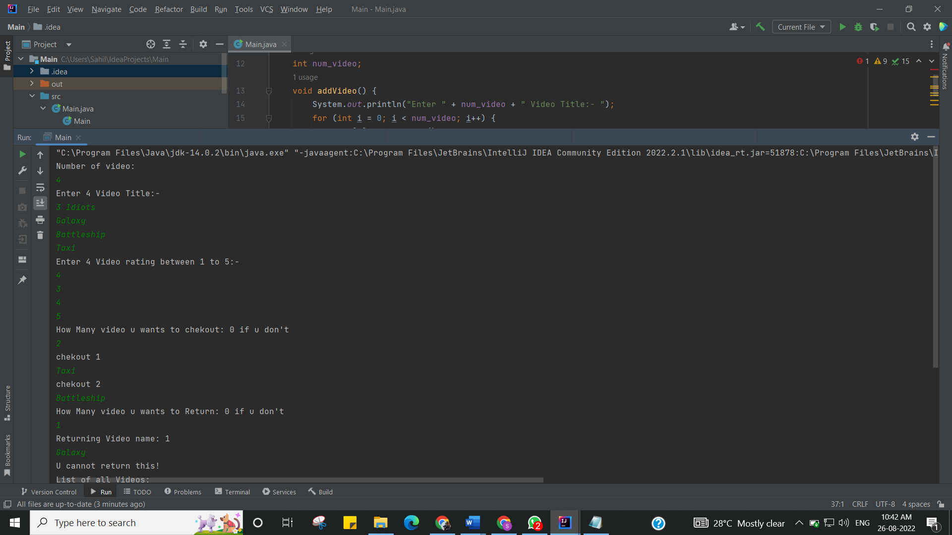

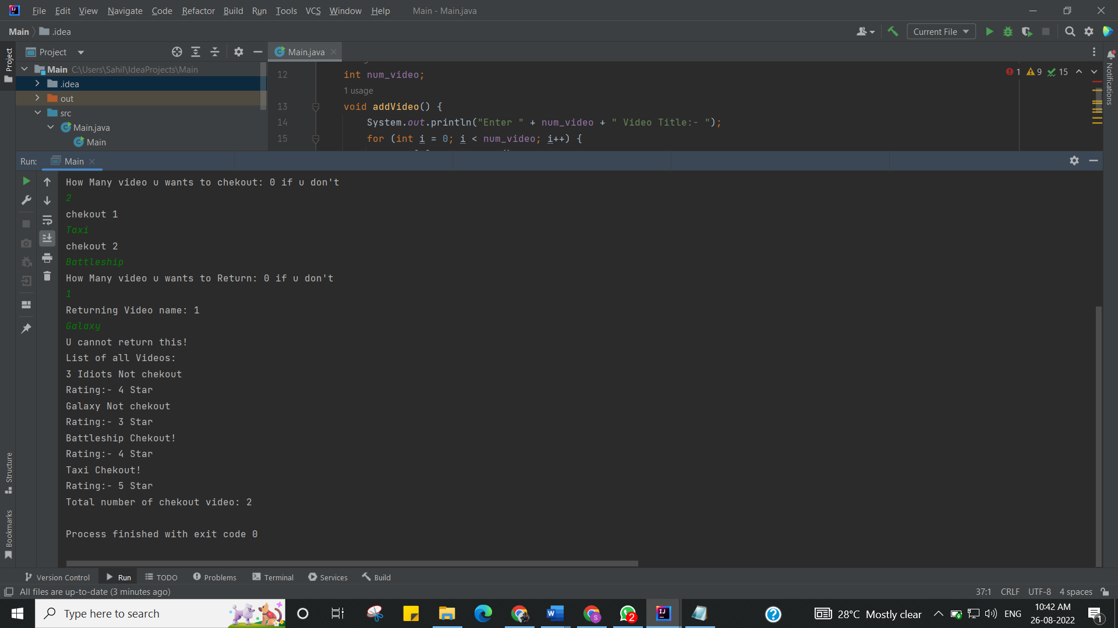

I have successfully done this program.

**Learning Outcomes (What I have learnt):**

1. Learn How use the inheritance concept.
2. java classes and all the features.

**Evaluation Grid (To be created as per the SOP and Assessment guidelines by the faculty):**

|  |  |  |  |
| --- | --- | --- | --- |
| Sr. No. | Parameters | Marks Obtained | Maximum Marks |
| 1. |  |  |  |
| 2. |  |  |  |
| 3. |  |  |  |
|  |  |  |  |